Recurrent Neural Networks (RNNs)

CNNs excel at understanding images by exploiting spatial structure, but what about data that unfolds over time? Consider a sentence: "The cat sat on the ___." To predict the missing word, understanding individual words isn't enough as the meaning emerges from their sequence and relationships. This is where Recurrent Neural Networks (RNNs) transform the landscape. Unlike feed-forward networks that treat each input independently, RNNs maintain memory of previous inputs through recurrent connections, allowing them to capture temporal dependencies in sequential data. [Add here the goal of the course]
1. Understanding Recurrent Architecture
1.1 From Feed-Forward to Recurrent: The Key Difference
Traditional feed-forward neural networks process inputs in one direction: data flows from input layer through hidden layers to output, with no backward or lateral connections. Each prediction is independent: the network has no memory of previous inputs. This architecture works brilliantly for tasks where each example stands alone, like classifying individual images.
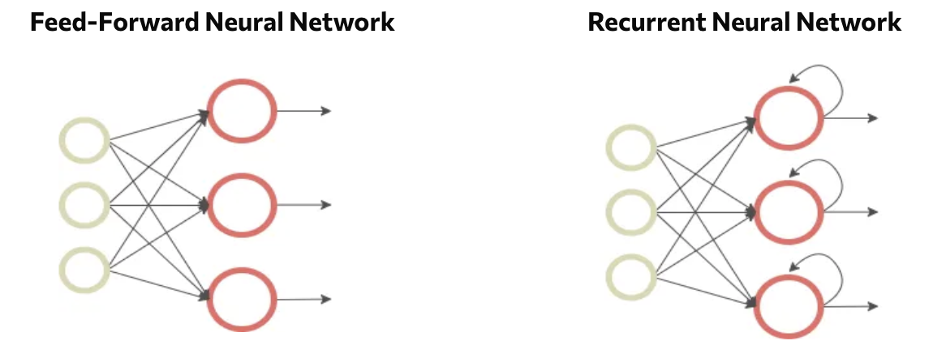
Figure - Feed-Forward vs Recurrent Networks: Feed-forward networks (left) process inputs independently, while recurrent networks (right) maintain connections that loop back, creating memory.
Recurrent Neural Networks fundamentally change this paradigm by introducing connections that loop back on themselves. Each neuron doesn't just send its output forward but it also feeds it back as input for the next time step. This creates a form of memory, allowing the network to maintain information about previous inputs while processing new ones.
The critical innovation: RNNs share the same weights across all time steps. Rather than learning separate parameters for each position in a sequence, the network learns a single set of transformations applied repeatedly. This weight sharing enables RNNs to handle sequences of arbitrary length and generalize patterns across different temporal positions.
Intuition: Think of a feed-forward network as reading words on flashcards, each card is processed independently with no memory of previous cards. An RNN is like reading a book, each word is understood in the context of what came before, with the same reading comprehension skills (weights) applied throughout.
1.2 Hidden States: The Memory Mechanism
The magic of RNNs lies in their hidden state: a vector that serves as the network's memory. At each time step, the hidden state combines two pieces of information:
- The current input $x_{t}$ (what's happening now)
- The previous hidden state $h_{t-1}$ (what the network remembers from before)
The mathematical formulation captures this elegantly:
$$h_{t}=f(W_{hh}⋅h_{t-1}+W_{xh}⋅x_{t}+b)$$
where:
- $h_{t}$ is the new hidden state
- $W_{hh}$ weights the previous hidden state (memory)
- $W_{xh}$ weights the current input
- $f$ is an activation function (typically tanh or ReLU)
- $b$ is a bias term
The output at each step is computed from the hidden state:
$$y_{t}=W_{hy}⋅h_{t}+b_{y}$$
This hidden state acts as a running summary of everything the network has seen so far, continuously updated as new inputs arrive. It's both the network's memory and its working context for making predictions.
Practical insight: The hidden state's dimensionality is a crucial hyperparameter. Too small, and the network can't remember enough context. Too large, and training becomes computationally expensive with potential overfitting. Typical sizes range from 128 to 512 dimensions, depending on task complexity.
2. RNN Mechanics and Processing
2.1 Rolled vs Unrolled Representations
RNNs can be visualized in two equivalent ways, each offering different intuitions:
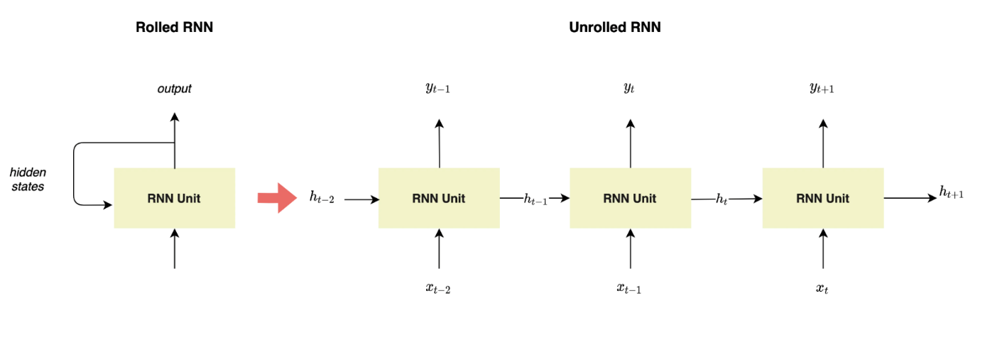
Figure - Rolled vs Unrolled RNN: The rolled view (left) shows the recurrent connection compactly, while the unrolled view (right) reveals the network's behavior across time steps.
Rolled representation (left) shows the RNN as a single unit with a loop—a compact view emphasizing that the same network processes each time step. The loop represents the hidden state feeding back into itself.
Unrolled representation (right) "unfolds" the network across time, showing separate copies of the same RNN unit for each time step. This view makes explicit how information flows through the sequence: each unit receives input $x_{t}$, previous hidden state $h_{t-1}$, produces output $y_{t}$, and passes hidden state $h_{t}$ forward.
2.2 Processing Sequential Data
RNNs handle sequences through a simple but powerful loop. At each time step $t$:
- Receive input $x_{t}$ (e.g., a word embedding, sensor reading, price value)
- Combine it with the previous hidden state $h_{t-1}$
- Compute new hidden state $h_{t}$ using learned weights
- Generate output $y_{t}$ (if needed at this step)
- Pass $h_{t}$ forward to the next time step
This process repeats for the entire sequence. The same weights ($W_{hh}$, $W_{xh}$, $W_{hy}$) are used at every step: the network learns patterns that apply across time.
Variable-length sequences pose no problem. A sentence with 5 words processes 5 time steps; a sentence with 20 words processes 20 steps. The same RNN handles both, unlike fixed-architecture networks requiring predetermined input sizes.
Different tasks use RNNs differently:
- Sequence-to-sequence: Input sequence → output sequence (translation, video captioning)
- Sequence-to-one: Input sequence → single output (sentiment analysis, sequence classification)
- One-to-sequence: Single input → output sequence (image captioning, music generation)
3. Advanced RNN Architectures
3.1 The Vanishing Gradient Challenge
Standard RNNs face a fundamental problem: the vanishing gradient issue. During backpropagation through time, gradients must flow backward through many time steps. At each step, they're multiplied by weight matrices and derivatives of activation functions.
When these multiplications repeatedly involve values less than 1, gradients shrink exponentially: they "vanish." By the time gradients reach early time steps, they're effectively zero, meaning the network can't learn long-term dependencies. It struggles to connect information separated by more than 10-15 time steps.
Example: In the sentence "The chef, who trained in Paris and won multiple awards, carefully prepared the ___," an RNN needs to remember "chef" across many intervening words to predict "meal" or "dish." Vanishing gradients make this difficult: the network forgets "chef" by the time it reaches the blank.
Conversely, gradients can sometimes explode rather than vanish, growing exponentially and destabilizing training. Both problems stem from the same root cause: naive recurrent connections struggle with long sequences.
3.2 LSTM and GRU: Gated Solutions
Two specialized RNN architectures address these limitations through sophisticated gating mechanisms that control information flow:
LSTM (Long Short-Term Memory) introduces three gates:
- Forget gate: Decides what information to discard from cell state
- Input gate: Determines what new information to store
- Output gate: Controls what information to output based on cell state
These gates use sigmoid activations (outputting 0-1) to selectively allow or block information, creating explicit pathways for gradients to flow unchanged across many time steps.
GRU (Gated Recurrent Unit) simplifies LSTM with two gates:
- Reset gate: Controls how much past information to forget
- Update gate: Decides how much to update the hidden state
GRUs combine the forget and input gates into a single update gate, making them computationally more efficient while achieving similar performance.
Both architectures solve the vanishing gradient problem through these gates, enabling learning of dependencies spanning hundreds of time steps. They've become the default choice for most sequence modeling tasks, with basic RNNs rarely used in practice.
Practical guidance: Start with LSTM for most applications as it's well-established with extensive documentation and pretrained models. Use GRU when computational efficiency matters or when working with smaller datasets. Basic RNNs are primarily of historical and pedagogical interest.
Key Takeaways
- Recurrent Neural Networks process sequential data by maintaining hidden states that serve as memory, with recurrent connections feeding information from previous time steps back into the network at each new step
- The key innovation is weight sharing across time steps—the same parameters process each element of a sequence, enabling RNNs to handle variable-length inputs and generalize temporal patterns
- RNNs can be visualized as rolled (compact, showing the recurrent loop) or unrolled (expanded across time steps), with both representing identical computations and the unrolled view clarifying backpropagation through time
- Standard RNNs suffer from vanishing gradients when learning long-term dependencies, as gradients exponentially decay when backpropagating through many time steps
- LSTM and GRU architectures solve the vanishing gradient problem through gating mechanisms that create explicit pathways for gradient flow, making them the practical choice for real-world sequence modeling tasks

